# ***Call Center Simulation in NS-3 and Node.js***

# ***Advisor: Dr. Tariq Mahmood Jadoon***

* **Erlang C, Erlang X and Optimized Call Center Model Simulation in NS-3.26.**
* **Comparison of performance metrics with Real Call Center Records.**
* **Call Center implementation using HTTPS Server, RTCPeerConnection and Socket.io in Node.js.**

***Call Center Simulation in NS-3***

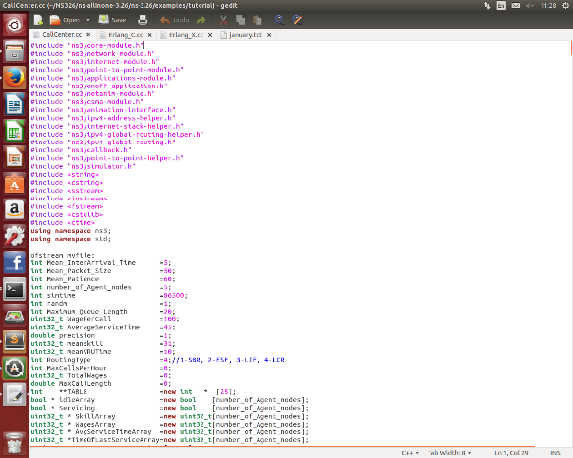 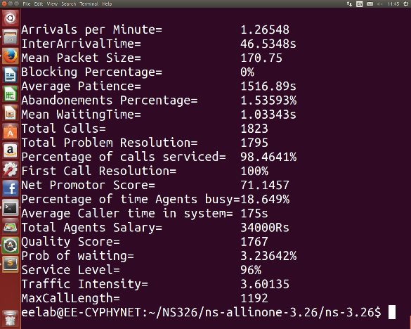

***NetAnim Animation***

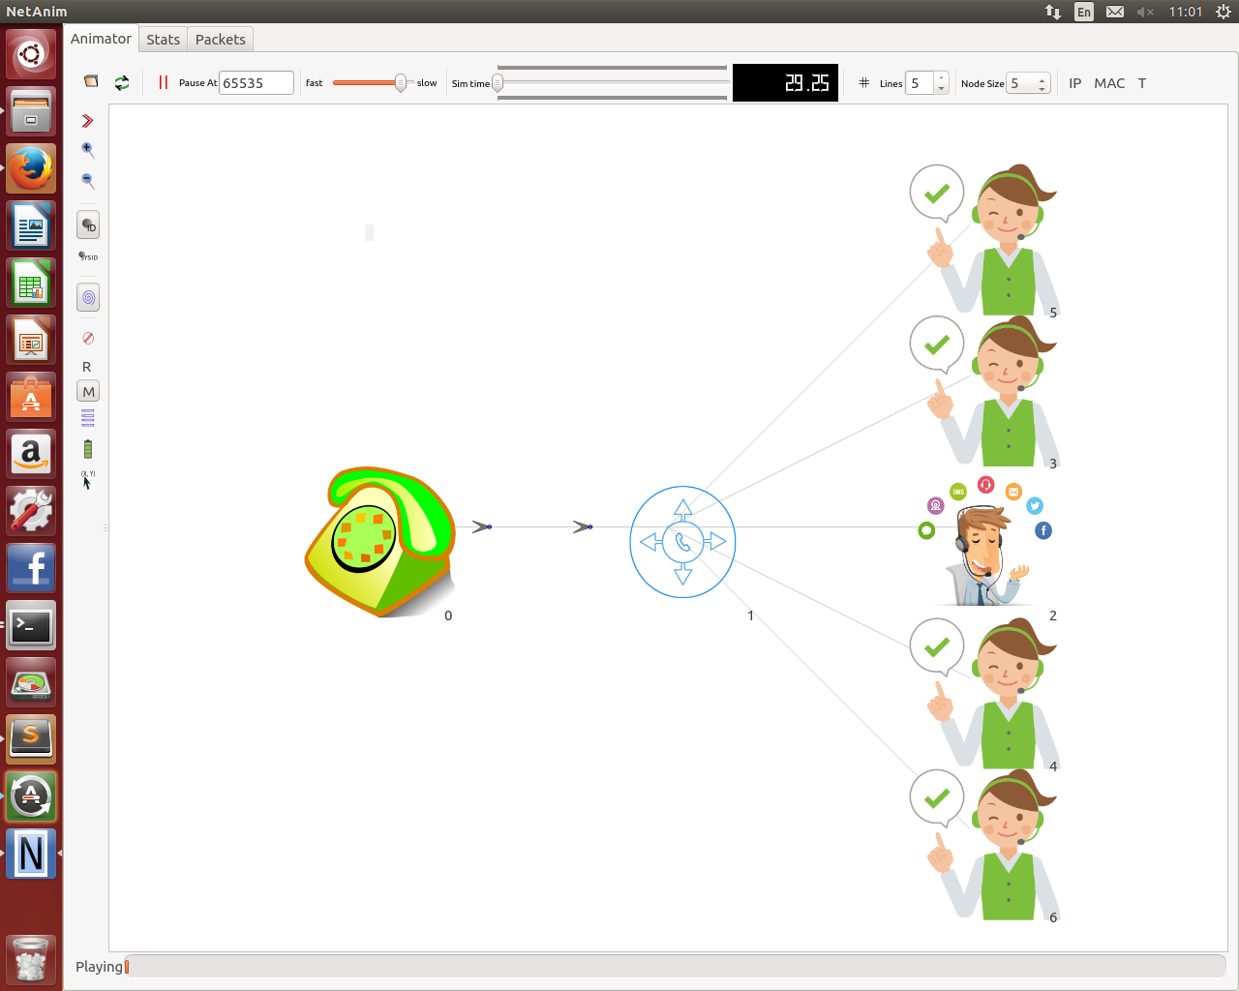

***Call Center Simulation in Node.js***

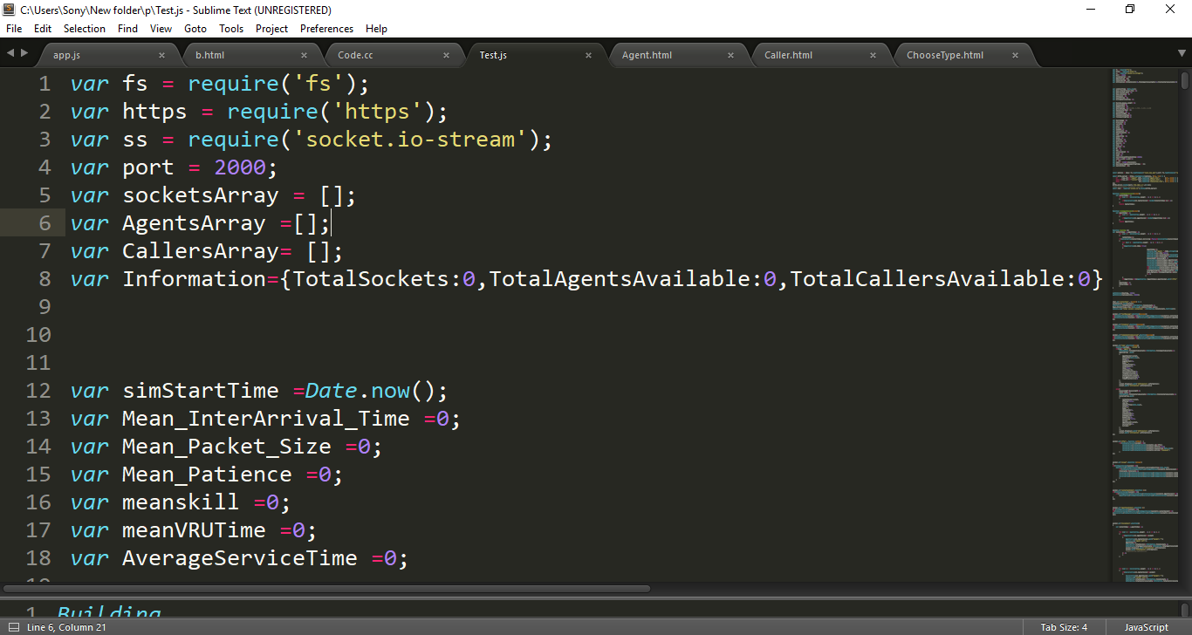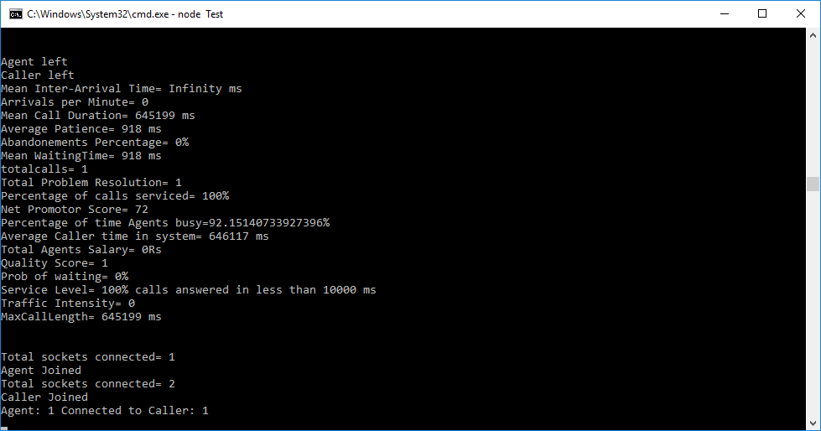

***Caller and Agent Web Pages***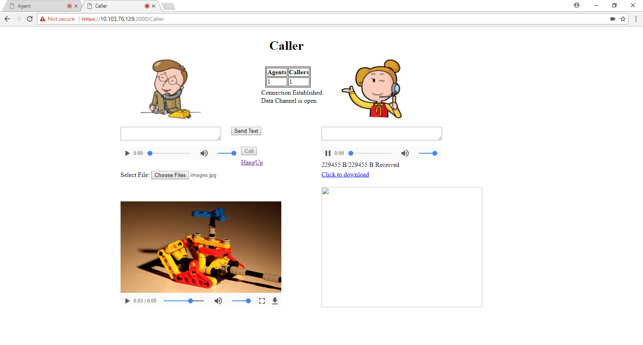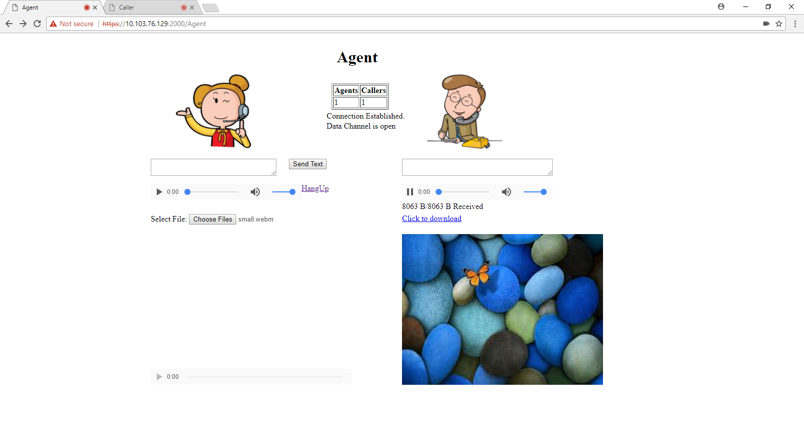

***Group Members***

 

Muhammad Shamaas Ammarah Azmat

 

Hira Tariq Zarmeen Khan